Fielder’s choice

“FC” is also used in the first base square to indicate that the batter-runner’s advance to first was as a result of fielder’s choice. Unlike the occupied ball notation, however, which is always preceded by one or more fielding chances, “FC” is used when the alternative play, despite being correctly executed by the defense, does not result in a putout.
Therefore, fielder’s choice shall not be considered as a fielding chance (defensive opportunity).
The notation to use is “FC” followed by two numbers, the first representing the fielder who initiated the play and the second identifying the base towards which he threw.
Example 71: The infield ground ball is recovered by the third baseman who chooses to play for the forced runner, and fails to make the putout.
This also indicates that when an infield ground ball is recovered by the second baseman, who chooses to play for the forced runner and throws to the shortstop, but fails to make the putout, we score FC44 for the batter (the first 4 is the fielder who initiated the play and the second 4 is the base towards hethrew).
WBSC |  | Traduction dans l’outil de scorage |  | Outil
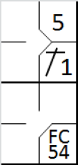 |  | /* Le premier batteur frappe un simple sur le lanceur */  action { batter -> 1B1 }  /* Le batteur suivant frappe une balle vers le défenseur de la troisième base qui fait le choix de relayer la balle au défenseur de la deuxième base sans succès */  action { batter -> FC54 , runner1 -> + } |  | 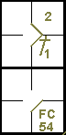

The notation “FC” in the first base square indicates that a play for that base would have led to the batter-runner being put out, as demonstrated in the example 72.
WBSC |  | Traduction dans l’outil de scorage |  | Outil
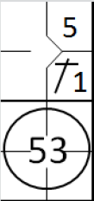 |  | /* Le premier batteur frappe un simple sur le lanceur */  action { batter -> 1B1 }  /* Le batteur suivant frappe une balle vers le défenseur de la troisième base qui relayer la balle au défenseur de la première base pour retire le batteur coureur */  action { batter -> 53 , runner1 -> + } |  | 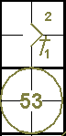

Example 73: In the event that the scorer is not convinced that the batter would have been put out on first base, the result would be a safe hit.
WBSC |  | Traduction dans l’outil de scorage |  | Outil
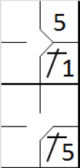 |  | /* Le premier batteur frappe un simple sur le lanceur */  action { batter -> 1B1 }  action { batter -> 1B5 , runner1 -> + } |  | 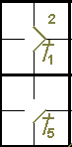

Example 74: With first and second bases occupied, on a buntby the ninth batter the pitcher tries unsuccessfully to put outthe forced runner on third, thus giving the batter-runner the opportunity to reach first base.
WBSC |  | Traduction dans l’outil de scorage |  | Outil
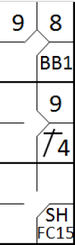 |  | /* Le premier batteur gagne la première base sur un 'base on ball' */  action { batter -> BB }  /* Le batteur suivant frappe un hit sur la deuxième base, le coureur avance en deuxième base */  action { batter -> 1B4 , runner1 -> + }  /* Le batteur frappe un bunt sacrifice, mais la défenseur fait le chois de retirer le coureur en 2 sans succès */  action { batter -> SHFC15 , runner1 -> +, runner2 -> + } |  | 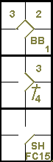

Example 75: If, in the action described above, the lead runner had been put out (or had reached base safely on an error by one of the two fielders who took part in the action), the batter-runner’s arrival on first base would have been recorded as an “occupied ball”.
WBSC |  | Traduction dans l’outil de scorage |  | Outil
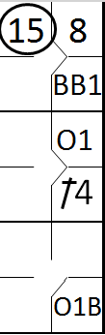 |  | /* Le premier batteur gagne la première base sur un 'base on ball' */  action { batter -> BB }  /* Le batteur suivant frappe un hit sur la deuxième base, le coureur avance en deuxième base */  action { batter -> 1B4 , runner1 -> + }  /* Le batteur suivant frappe un bunt sur le lanceur qui récupère la balle et fait le choix d'éliminer le coureur arrivant en 3 */  action { batter -> O1b , runner1 -> O1 , runner2 -> 15 } |  | 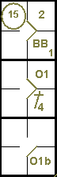

The example 76 shows what happens when there is no opportunity to retire any of the runners.
WBSC |  | Traduction dans l’outil de scorage |  | Outil
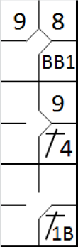 |  | /* Le premier batteur gagne la première base sur un 'base on ball' */  action { batter -> BB }  /* Le batteur suivant frappe un hit sur la deuxième base, le coureur avance en deuxième base */  action { batter -> 1B4 , runner1 -> + }  /* Le batteur suivant frappe un bunt sur le lanceur qui récupère la balle et relance la balle pour retirer le coureur arrivant en 3 sans succès */  action { batter -> 1B1b , runner1 -> + , runner2 -> + } |  | 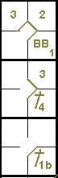
ATTENTION: When, in such a play, the scorer judges that the defense would not have been able to make any other putouts, including the batter-runner, the batter-runner must be credited with a safe hit.
Example 77: The seventh batter swings at the third strike,which is missed by the catcher. Despite recovering the ball in time to make the putout on first, the catcher tries to put outthe runner who left his base on the passed ball. The runner reaches base safely.
WBSC |  | Traduction dans l’outil de scorage |  | Outil
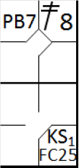 |  | /* Le premier batteur frappe un double dans le champ centre */  action { batter -> 2B8 }  /* Troisième strike relâché sur un pass ball, le receveur fait le chois de retirer le coureur arrivant en trois sans succès */  action { batter -> KSFC25 , runner2 -> PB } |  | 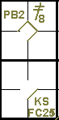
The advance to third occurs on a passed ball, while the batter-runner’s advance to first is recorded as “FC”, preceded by the strike and the cumulative strikeout number, and followed by the number of the catcher who made the throw and the number of the base to which the alternative play was made.
The example 78 shows the effects of a successful play for first base. No passed ball is charged to the catcher, because of the out.
WBSC |  | Traduction dans l’outil de scorage |  | Outil
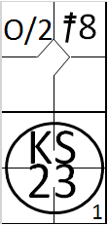 |  | /* Le premier batteur frappe un double dans le champ centre */  action { batter -> 2B8 }  /* Troisième strike relâché sur un pass ball, le receveur retrait du batteur coureur par une relance au première base */  action { batter -> KS23 , runner2 -> O/2 } |  | 

